DOWNLOADABLE ACCIDENT AND PATIENT REPORT FORM FOR PERSONAL FIRST AID
HOW TO USE THIS FORM
In the event of an accident you may be in a position where you have to summon help and give prolonged care to a close companion or friend. This will be very stressful even if you are used to this type of work. The most important principles of first aid in a remote area are: COMMAND CONTROL COMMUNICATIONS followed by good protection from the environment and then practical first aid.
Without good communications help will not arrive where and when needed. Communications will consist of verbal communications by direct contact, phone or radio. Sound communications by whistle (6 blasts). Visual communications by signals such as torch (6 flashes). Any communication when anxious and scared may be confused so by filling in these forms prior to sending a message you will ensure that the correct information is given coherently. The time spent completing these forms will ultimately speed up the arrival of appropriate help.
The first form is an Accident Report. It is one side of A4. It is designed to be used to summon help. If necessary it can be sent with a messenger or transmitted by phone or radio.
The second form is a two sided Patient Report Form and several copies should be carried so one can live with each patient until arrival at hospital. It is designed to evolve over the period of care. It is “multilingual” in that injuries and areas of pain can be indicated simply by annotating the diagram of the patient.
I would suggest downloading the forms and if possible printing them onto waterproof paper (available from: http://www.memorymap.co.uk/acatalog/accessories_waterproof_paper.html ). Carry them in your personal first aid kit with a small pencil sharpened at both ends.

ACCIDENT REPORT FORM
SITE: Name:
Address:
DATE & TIME:
WEATHER: Wind: Cloud: Visibility: Tide:
PATIENTS: 1) Name: Age:
Problem/Injuries suspected:
2) Name: Age:
Problem/Injuries suspected:
3) Name: Age:
Problems/Injuries suspected:
HELP WANTED: People:
Equipment:
PEOPLE AT SCENE:
EQUIPMENT AT SCENE:
POSSIBLE APPROACH:
NAME & ADDRESS & TEL No OF INFORMANT:
PATIENT REPORT FORM
NAME : Date & Time :
Age :
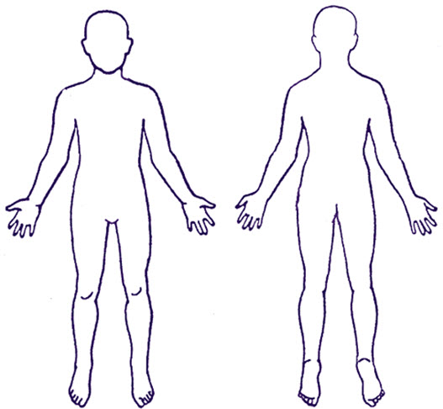
HISTORY OF INCIDENT :

Pulse : Spine :
Conscious ?
Allergies :
Regular Medication :
Past Medical History :
Name & Address of First Aider :

PATIENT PROGRESS REPORT
Time Pulse Pupils Level of Consciousness (AVPU) Other Changes
TREATMENT GIVEN :
DRUGS GIVEN :
Drug : Dose : Route : Time :

